

CEBD 1151 - Big Data Analytics for Business

[Team] Assignment - Exploratory Data Analysis Assignment

Team members: Michal Velhartický and Omar Bennani

Submission date: 17/10/2020

**Sum of Yearly Fish Catches for each Sub-Area**

The Northeast Atlantic Region (FAO major fishing area 27) is composed of 13 sub-areas, which are further divided in divisions, sub-divisions and units. For the purpose of illustrating the distribution of this predictor and the relationship with the target, we limit the grouping of the data by sub-area. Only the years 2011-2016 are shown as predictors to make it easier to visualise the data as well as the year 2017 as a target for validation. The year 2018 is not included in this step since it will be used for testing. On the y axis, the total number of fish catches per sub-area is represented by a bar graph for years 2011-2016 and the total number of fish catches per sub-area for the target year 2017 is represented by a line graph. We notice that the number of fish catches for the target line is the highest value on average when compared to previous years. It is also observed that the sub-areas 27.2, 27.4 and 27.5 have the largest number of fish catches over the years. Overall, it seems that the number of fish catches per sub-area is increasing over the years in some cases and is stable or decreasing in fewer cases. After creating, validating and testing a model using the previous years data as predictors and the target years 2017 (validation) and 2018 (testing), it can be expected that the number of fish catches will increase for each sub-area when applying the model to predict future years.

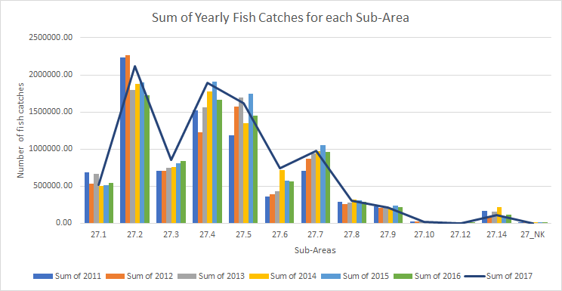

**Sum of Yearly Fish Catches for the top 10 Most Caught Species**

There are 11564 species that are fished in the Northern Atlantic. For our purpose we chose the list of top 10 that are also the commercially known species. This graph represents the most caught species of fish in the chosen period of years 2011 to 2016. Each column and its colour represents the total sum of catches of the listed species.

The most caught fish is Atlantic Herring, Atlantic Cod and Atlantic Mackerel. The lower of the end of the list of top 10 is Atlantic horse mackerel, Saithe and Sandeels. The dark blue line represents the total catches for 2017. This is the year we are trying to predict based on the previous years. In detail, the meaning of the line if it is above the bar, there’s expected growth in annual catches. On the opposite where the line drops into the bars the catches are on decline.

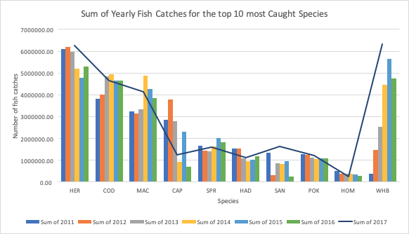

Fish species dictionary:

HER - Atlantic Herring COD - Atlantic Cod

MAC - Atlantic Mackerel CAP - Capelin

SPR - European sprat HAD - Haddock

SAN - Sandeels POK - Saithe

HOM - Atlantic horse mackerel WHB - Blue whiting

**Sum of Yearly Fish Catches for each country**

The graph contains a list of 21 countries that fish in the North Atlantic and their total catches of all species in years 2011 to 2016. It is important to notice that they are organised from the country with the highest catches to the lowest. The country with the most catches is Norway, Island and Russia. Isle of Man, Belgium and Latvia are least fishing countries in the North Atlantic. Each bar represents total catches of the country where the colour represents the year. The blue line, as in the previous graph, shows the relation of assumed prediction of catches in 2017 with the previous years. If it falls into a bar, the prediction is on decline and if above the bars, the total catches are expected to rise.

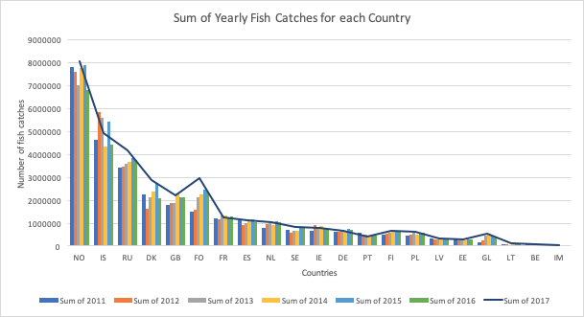

Country dictionary:

NO - Norway IS - Island RU - Russia

DK - Denmark GB - Great Britain FO - Faroe Island

FR - France ES - Spain NL - Netherlands

SE - Sweden IE - Ireland DE - Germany

PT - Portugal FI - Finland PL - Poland

EE - Estonia LV - Latvia BE - Belgium

IM - Isle of Man